Survey of Hydrologic Impacts on Jacob’s Well, Wimberley, Texas

PROGRESS REPORT


Taylor Made Mapping
Project Manager: Dorothy Taylor
GIS Analyst: Erin Sellers
GIS Analyst: Larry Cheever
Metadata Specialist: Roy Koenig

Taylor Made Mapping
April 4, 2007

To: Michael Pape, Wimberley Valley Watershed Association
From: Dorothy Taylor, Project Manager for Taylor Made Mapping
Subject: Progress report on Jacob’s Well mapping project

Introduction:
In late February 2007, Taylor Made Mapping submitted a proposal to Wimberley Valley Watershed Association (WVWA). The proposal contained our plans to provide WVWA with three groups of maps to help them better communicate the importance of Jacob’s Well to various audiences. After the proposal was accepted, we began work on the project, which is scheduled for completion on May 4, 2007. The following progress report will provide an up to date list of data that has already been gathered, work in progress and work that we have not yet started. This report will conclude with an overall appraisal of how the project is progressing.

Project Description:
Review of General Purpose and Scope:
The object of this study is to display Jacob’s Well and its surrounding areas, so that WVWA can better communicate the importance of the spring to local authorities, policy makers, and the general public as well as to determine steps necessary to protect it in the future. By identifying parcels located along fault lines and inside the watershed containing Jacob’s Well, we will help WVWA learn where they should concentrate their efforts in purchasing development rights. This will in turn have a significant impact on reducing the amount of water taken directly from the sources of Jacob’s Well. The scope of our study will encompass at least three scales: 1. The smallest scale will be of the Blanco River watershed, including Hays County, and portions of Comal, Blanco and Kendall Counties. 2. The intermediate scale will encompass the Wimberley/Woodcreek vicinity. 3. The largest scale will be of the WVWA offices and property boundaries.

DATA STATUS:
Below is a list of the data that we plan to use and the current status of each
 | Description | Status | Source
 | Aqua Texas Well Locations | Have | Primary - Field Collected
 | River Rock Development – New parcel locations | Have | River Rock Development Website
 | Blanco Watershed | Created with ArcHydro Tools | Primary - Created
 | Fault Line Locations | Have | United States Geological Survey
 | Hays Co. Parcels | Have | Capital Area Council of Governments
 | Comal Co. Parcels | Have | Comal County
 | Blanco Co. Parcels | Will be picked up soon | Blanco County
 | Kendall Co. Parcels | Will be mailed soon | Kendall County
 | Wimberley City & ETJ | Have ETJ – City file not working | City of Wimberley
 | DEM – Hays County | Have | U.S.G.S.
 | Creeks & Streams, Well Data in areas | Have | Texas Natural Resources Information System (TNRIS)
 | Roads | Have | TNRIS
 | Wimberley Valley Watershed Association Property | Have | Hays Cad
 | Color Photo | Have Naip 2004 1m Image | TNRIS
 | Photo’s of Area | Have Blue Hole and Jacob’ Well | Primary – Field Collected
 | Cabins & Trails | Waiting for info | WVWA

Work Accomplished:
As you can see from the table above the majority of the data has already been collected. Larry was able to create the Blanco River Watershed using ArcHydro Tools, giving us a very accurate representation of the watershed. The Fault lines have been located and we have identified the parcels that are located above the fault lines. We have obtained parcels from Hays, Comal and Blanco Counties. We are waiting for a reply on parcels from Kendall County. The parcels that make up the WVWA property have been identified and combined into a single parcel to be displayed in the Site Map. Eight Aqua Texas Well location coordinates have been identified. We have created a template for the map groups.

Work in Progress:
Below you will see our Watershed map in progress. The parcels within the watershed, that have fault lines running through them have been identified. There are over 1000 parcels affected, we can give you a list of parcel numbers selected. The fault lines within the Blanco River Watershed only occur within Hays and Comal Counties. We can limit the parcels to the ones that are within the Trinity Aquafer as well, thus reducing the number to parcels that would actually affect water going to Jacob’s Well to 654 parcels. We should be able to add the Blanco and Kendall parcels very soon.

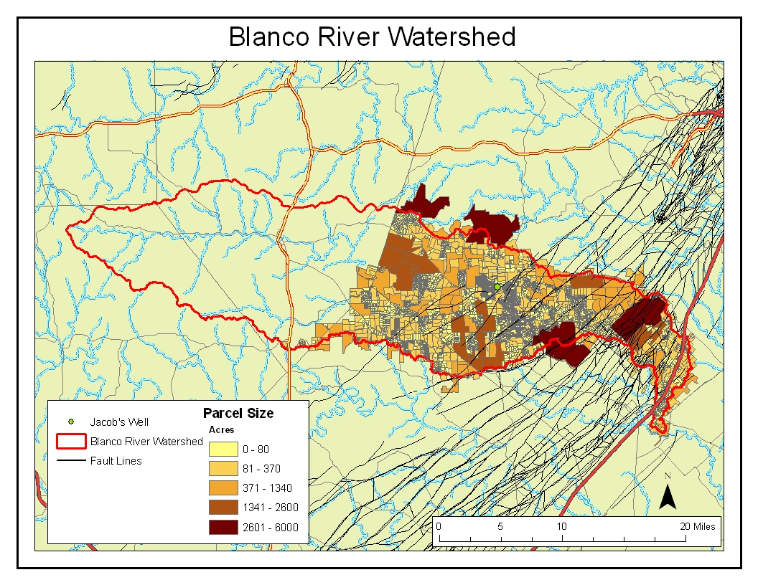

The nearby proposed River Rock development has been identified and we are creating symbols to show the intended location of buildings.

Our website has been created and has several pages. It will be updated as the project progresses. It can be accessed at this site: http://geosites.evans.txstate.edu/~g4427s07-05/JacobsWellSite.html The homepage is shown below.



Work Planned:

Work on all three map groups has begun. We need to import the Aqua Texas well locations into our small scale map. We have obtained some photographs of the area, such as Blue Hole in Wimberley to be placed as insets within the intermediate scale. We will show the Wimberley city limits and ETJ. We had understood that you would like to have your current site plan updated. We are somewhat unclear as to exactly what you want shown on this large scale map. We need to meet to discuss what you want shown on this map.

Revised Timeline:
Project Week | 9 | 10 | 11 | 12 | 13
Week Ending | Apr. 6 | Apr. 13 | Apr. 20 | Apr. 27 | May 4
Data Collection
Data Processing
Website
Data Analysis
Data Interpretation
Editing and Final Deliverables

Revised Project Tasks:
Project | Work Completed | Current Work | Planned Work
Map 1A | Hays & Comal County parcels added, Watershed created | Add Blanco & Kendall County Parcels | Final Editing
Map 1B | Hays & Comal County parcels added, Watershed created, Fault Lines added | Add Blanco & Kendall County Parcels  Select Parcels over Fault Lines | Final Editing
Map 2A | Hays Parcels, WVWA Property, Wells Shown | Display Finished Map | Final Editing
Map 2B | Hays Parcels, WVWA Property | Adding U.S.G.S. Monitoring Stations | Is this map useful to you?
Map 2C | Creeks, Streams, Parcels, Jacob’s Well added | Show Blue Hole location | Get Photo of Jacob’s Well
Map 3A | Same as 2C | Adding River Rock Development Bldgs. | Add
Map 3B | Parcels and Photo added | What are your needs? | Add Items and Final Edit
Final Project Description:
The final project that will be provided to WVWA will include the following:

- Detailed Final Report (2 copies)
- A bound portfolio of all maps created (11x17)
- Excel List of Selected Parcel Numbers
- Professional Quality Poster
- Website containing:
  - Project documents
  - PowerPoint presentations

- CD (2 copies) containing:
  - All data
  - Metadata
  - Report
  - .jpeg images of all maps.
  - Poster
  - PowerPoint Presentation
  - CD use instructions in the form of a readme file.

Conclusion:
The study of Hydrologic impacts on Jacob’s well project for WVWA is progressing well. Taylor Made Mapping has acquired the majority of the data needed for the project. We are only lacking the Wimberley City limits. This has caused our time for Data Collection and Processing to be extended, but I do not see that it will delay the project completion date. Most of the analysis has been completed and the website is ready for input. At this point, we need to discuss the questions highlighted in the project tasks table, so the project can be completed on time. We are starting the editing process for the maps and getting ready to compile the final deliverable package. I feel confident that we will have the above stated project and presentation ready for you as promised on May 4, 2007.

Sincerely,
Dorothy Taylor
Project Manager, Taylor Made Mapping

